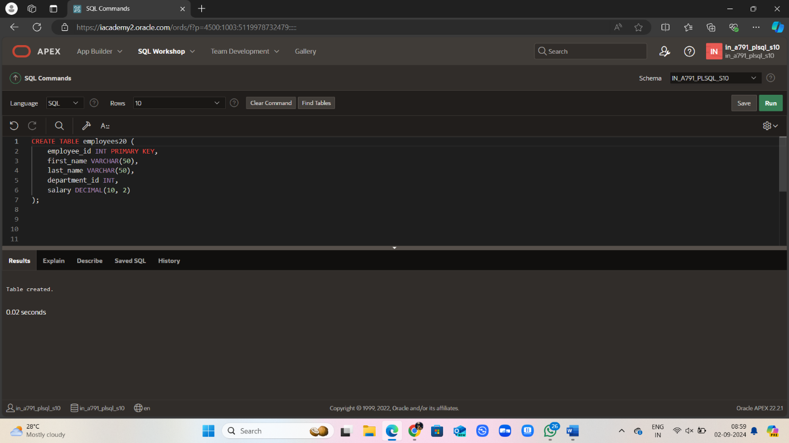

CREATE TABLE employees20 (

employee_id INT PRIMARY KEY,

first_name VARCHAR(50),

last_name VARCHAR(50),

department_id INT,

salary DECIMAL(10, 2)

);

INSERT INTO employees (employee_id, first_name, last_name, department_id, salary)

VALUES

(1, 'John', 'Doe', 10, 5000.00),

(2, 'Jane', 'Smith', 10, 6000.00),

(3, 'Michael', 'Johnson', 10, 7000.00),

(4, 'Emily', 'Davis', 20, 4500.00),

(5, 'David', 'Wilson', 20, 5500.00)

SELECT o.first_name, o.last_name, o.salary

FROM employees20 o

WHERE o.salary >

(SELECT AVG(i.salary)

FROM employees20 i

WHERE i.department_id = o.department_id);

